Detailed Report
On
Texas Instruments C2000 F28379D
LaunchPad — Internship Project Report

Submitted by : Bobby Prashant U23EE096
Ruchita Parmar U23EE113

Guided by :
Dr. Sanjay Tolani
Dr. Rajshekhara R.Chilipi
Miss Astha (Phd. Scholar)



Department of Electrical Engineering
Sardar Vallabhbhai National Institute of Technology, Surat

1. Texas Instruments C2000 Microcontroller
Texas Instruments (TI) C2000 is a family of 32-bit real-time microcontrollers designed specifically for control applications in power electronics, motor drives, renewable energy, industrial automation, and embedded systems. Unlike general-purpose MCUs, C2000 devices are optimized for deterministic, high-speed closed-loop control — making them the industry standard in applications such as digital power supplies, inverters, motor controllers, and grid-tied converters.

1.1 Key Features of the C2000 Family
- 32-bit Harvard architecture based on the TMS320C28x CPU core
- Clock speeds up to 200 MHz on dual-core variants
- Enhanced PWM (ePWM) modules with dead-band, trip-zone, and high-resolution capability
- 12-bit and 16-bit ADC modules with simultaneous sampling
- Serial Communication Interfaces: SCI, SPI, I2C, CAN, USB
- Fast interrupt response and hardware-accelerated trigonometric functions (TMU)

1.2 TMS320F28379D — The Dual-Core Powerhouse
The TMS320F28379D (F28379D) is the flagship device of the C2000 Delfino series. It features two independent C28x CPU cores (CPU1 and CPU2), each capable of running at 200 MHz. This dual-core architecture enables true concurrent execution — for example, CPU1 can manage control loops while CPU2 handles communications or diagnostics simultaneously.

Parameter | Specification
Architecture | Dual-core TMS320C28x (32-bit) + 2× CLA
CPU Clock Speed | 200 MHz per core
Flash Memory | 1 MB (512 KB per core)
RAM | 204 KB (shared + local)
ePWM Channels | 24 (12 modules × 2 outputs each)
ADC Modules | 4 × 12-bit ADC (ADCA, ADCB, ADCC, ADCD)
DAC Channels | 3 × 12-bit buffered DAC
Communication | SCI, SPI, I2C, CAN, McBSP, USB
Operating Voltage | 3.3 V I/O, 1.2 V core
Package | 337-ball BGA / LQFP variants

1.3 LAUNCHXL-F28379D — The LaunchPad Evaluation Board
The LAUNCHXL-F28379D (also called the F28379D LaunchPad) is TI's low-cost evaluation and development board based on the TMS320F28379D. It provides easy access to the MCU peripherals via 80-pin BoosterPack connectors and includes on-board XDS110 JTAG debug probe, USB interface, and reference oscillator.

- On-board XDS110 debug probe — no external emulator required
- 2× LEDs (GPIO31, GPIO34) for quick output testing
- BoosterPack-compatible headers (80 pins)
- USB-C interface for power and debug
- JTAG and SCI/UART over USB virtual COM port

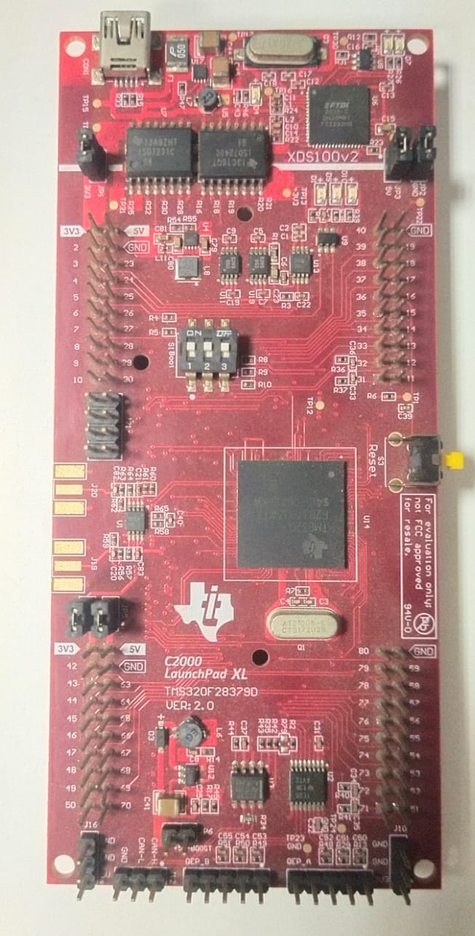

2. Software Prerequisites and Installation
To develop and deploy code on the F28379D LaunchPad, the following software components are required. Each must be installed in the order listed below.

2.1 Code Composer Studio (CCS) Installation
Code Composer Studio (CCS) is Texas Instruments' official Integrated Development Environment (IDE) based on Eclipse. It provides a complete toolchain including a C/C++ compiler, linker, debugger, and real-time expression monitor for all TI embedded devices.

Steps to Install CCS:
- Go to: https://www.ti.com/tool/CCSTUDIO
- Click 'Download' and select the installer for your OS (Windows recommended for F28379D development).
- Run the installer. When prompted to select components, ensure the following are checked:
- C2000 real-time MCUs (required for F28379D)
- XDS110 debug probe support (on-board JTAG)
- TI compiler tools (TI CGT for C28x)
- Complete the installation. Launch CCS from the Start Menu.
- On first launch, select a workspace folder (e.g., C:\Users\<name>\CCS_Workspace).

Recommended CCS version: CCS 12.x or later (supports all C2000 Delfino devices).

2.2 C2000Ware Installation
C2000Ware is TI's official software package for all C2000 microcontrollers. It contains the hardware abstraction layer (DriverLib), SysConfig tool integration, example projects, and device support files required for F28379D development. Without C2000Ware, the driverlib.h, device.h, and board.h headers used in all our codes will not be found by the compiler.

Steps to Install C2000Ware:
- Go to: https://www.ti.com/tool/C2000WARE
- Download the latest version of C2000Ware (e.g., C2000Ware_5_04_00_00).
- Run the installer and note the installation path (default: C:\ti\c2000\C2000Ware_x_xx_xx_xx).
- Inside CCS, go to: Window → Preferences → Code Composer Studio → Products.
- Click 'Add' and browse to the C2000Ware installation directory.
- CCS will discover C2000Ware and make all its libraries, headers, and examples available.

Important: C2000Ware includes two styles of library:
- DriverLib (driverlib.h) — High-level API (used in all our codes in this report)
- Peripheral Register Access (direct register writes) — Lower-level alternative

2.3 SysConfig (System Configuration Tool)
SysConfig is a GUI-based pin multiplexing and peripheral configuration tool integrated into CCS. For projects using board.h (such as the ePWM LED code), SysConfig generates the Board_init() function and associated header file automatically based on your peripheral setup.

How to use SysConfig in a project:
- When creating a new CCS project, select 'Use SysConfig' checkbox.
- A .syscfg file will appear in your project. Open it — SysConfig GUI launches.
- Add ePWM modules, GPIO configurations, ADC SOC settings visually.
- SysConfig auto-generates board.h and board.c with all init code.
- Build the project — CCS compiles the generated files automatically.

2.4 XDS110 USB Driver
The F28379D LaunchPad uses the TI XDS110 on-board debug probe. When the LaunchPad is first connected to a Windows PC via USB, Windows must install the XDS110 driver.

- Connect the LaunchPad via USB-C cable to your PC.
- Windows will attempt automatic driver installation. If it fails, open Device Manager.
- Right-click the Unknown Device → Update Driver → Browse to: C:\ti\ccs\ccs\ccs_base\emulation\windows\xds110.
- The XDS110 will appear as: XDS110 Class Application/User UART (COMx) in Device Manager.
- Note the COM port number — it is used for SCI/UART communication.

2.5 Creating a New CCS Project for F28379D
Follow these steps for every new project:
- In CCS: File → New → CCS Project
- Target: C2000 → TMS320F28379D
- Connection: Texas Instruments XDS110 USB Debug Probe
- Template: Empty Project (with main.c) or select an example from C2000Ware
- Enable 'Use DriverLib' and optionally 'Use SysConfig'
- Click Finish. Right-click project → Properties → Build → C2000 Compiler → Include Options → Add C2000Ware driverlib path

3. Code 1 — LED Blinking using GPIO

3.1 Objective
To understand the basic GPIO output configuration on the C2000 F28379D and blink the on-board LED (connected to GPIO31) at a fixed interval of 500 ms ON and 500 ms OFF using a software delay loop.

3.2 Prerequisites
- CCS installed and F28379D project created
- C2000Ware installed (provides driverlib.h and device.h)
- F28379D LaunchPad connected via USB (XDS110 driver installed)
- Basic understanding of GPIO direction modes and digital output

3.3 Complete Code
#include "driverlib.h"
#include "device.h"

void main(void)
{
// Initialize device clock and peripherals
Device_init();

// Initialize GPIO and configure the GPIO pin as a push-pull output
Device_initGPIO();
GPIO_setPadConfig(DEVICE_GPIO_PIN_LED1, GPIO_PIN_TYPE_STD);
GPIO_setDirectionMode(DEVICE_GPIO_PIN_LED1, GPIO_DIR_MODE_OUT);

// Initialize PIE and clear PIE registers. Disables CPU interrupts.
Interrupt_initModule();

// Initialize the PIE vector table with pointers to shell ISRs.
Interrupt_initVectorTable();

// Enable Global Interrupt (INTM) and realtime interrupt (DBGM)
EINT;
ERTM;

// Loop Forever
for(;;)
{
// Turn on LED
GPIO_writePin(DEVICE_GPIO_PIN_LED1, 0);

// Delay for 500 ms
DEVICE_DELAY_US(500000);

// Turn off LED
GPIO_writePin(DEVICE_GPIO_PIN_LED1, 1);

// Delay for 500 ms
DEVICE_DELAY_US(500000);
}
}
// End of File

3.4 Line-by-Line Explanation
Code Line / Block | Explanation
#include "driverlib.h" | Includes TI's DriverLib header — provides all peripheral API functions (GPIO, ADC, PWM, etc.) for C2000 devices.
#include "device.h" | Device-specific header for F28379D — defines Device_init(), clock macros, pin aliases like DEVICE_GPIO_PIN_LED1.
Device_init() | Initializes the device: sets up PLL (Phase-Locked Loop) for 200 MHz system clock, enables peripheral clocks, and configures clock gating registers.
Device_initGPIO() | Unlocks all GPIO pins and sets them to their default state (input, no pull-up/down). Must be called before any GPIO configuration.
GPIO_setPadConfig(..., GPIO_PIN_TYPE_STD) | Configures the GPIO pad as standard push-pull (no internal pull-up or pull-down resistor). Suitable for driving external LEDs and logic.
GPIO_setDirectionMode(..., GPIO_DIR_MODE_OUT) | Sets the GPIO pin as a digital output. The pin can now drive HIGH or LOW voltage levels.
Interrupt_initModule() | Initializes the Peripheral Interrupt Expansion (PIE) module — C2000's interrupt controller. Clears all interrupt flags and disables all peripheral interrupts.
Interrupt_initVectorTable() | Loads the default PIE vector table, which maps each interrupt number to its default (empty) Interrupt Service Routine (ISR).
EINT | Macro to enable global CPU interrupts — sets the INTM bit in the status register. Without this, no interrupts will be processed even if enabled in peripherals.
ERTM | Macro to enable real-time debug mode interrupts — clears the DBGM bit. Required for CCS debugger to work correctly during run-time.
for(;;) { ... } | Infinite main loop — keeps the MCU running continuously. Embedded systems typically never exit main().
GPIO_writePin(..., 0) | Writes logic LOW (0V) to the GPIO pin. On the F28379D LaunchPad, LED1 is active-low — writing 0 turns the LED ON.
DEVICE_DELAY_US(500000) | Software busy-wait delay of 500,000 microseconds (500 ms). Implemented using NOP (no-operation) instruction loops calibrated to the system clock.
GPIO_writePin(..., 1) | Writes logic HIGH (3.3V) to the GPIO pin — turns the LED OFF (active-low LED).

3.5 Key Concepts
- DEVICE_GPIO_PIN_LED1 is defined in device.h as GPIO31 on the F28379D LaunchPad.
- LEDs on the LaunchPad are active-low: a logic 0 output turns the LED on, and a logic 1 turns it off.
- DEVICE_DELAY_US is a calibrated busy-wait loop — it is blocking and consumes CPU cycles during the delay.
- In production code, timers or RTOS tick functions are preferred over busy-wait delays.

4. Code 2 — LED ON/OFF using ePWM (CMPA and CMPB)

4.1 Objective
To generate PWM outputs using the ePWM1 module with CMPA and CMPB compare values and observe the corresponding LED switching on GPIO31 (LED1) and GPIO34 (LED2). This demonstrates configuring the time base, compare units, shadow loading, and action qualifiers of the C2000 ePWM peripheral.

4.2 Prerequisites
- LED Blinking code completed — GPIO API familiarity required
- SysConfig installed and board.h generated for myEPWM1_BASE
- Understanding of PWM: time base period, up-down counting, duty cycle
- ePWM module clock enabled via SysCtl_enablePeripheral

4.3 Key Defines Explained
Define | Value | Meaning
TBPRD | 62500U | Time Base Period. With up-down count mode, TBCLK = SYSCLK / (CLKDIV × HSPCLKDIV) = 200M/(128×14) ≈ 111 kHz. Period = 2 × TBPRD / TBCLK ≈ 1.125 s.
CMPA | 31250U | Compare A value = TBPRD/2 → 50% duty cycle for ePWM1A output.
CMPB | 46875U | Compare B value = 75% of TBPRD → 25% duty cycle for ePWM1B output (LED2 ON for 25% of period).

4.4 Complete Code
#include "driverlib.h"
#include "device.h"
#include "board.h"

#define TBPRD 62500U
#define CMPA 31250U
#define CMPB 46875U

#define LED1_GPIO 31U
#define LED2_GPIO 34U

void main(void)
{
Device_init();
Device_initGPIO();
Interrupt_initModule();
Interrupt_initVectorTable();
Board_init();

// LED GPIO Configuration
GPIO_setPadConfig(LED1_GPIO, GPIO_PIN_TYPE_STD);
GPIO_setDirectionMode(LED1_GPIO, GPIO_DIR_MODE_OUT);
GPIO_setPadConfig(LED2_GPIO, GPIO_PIN_TYPE_STD);
GPIO_setDirectionMode(LED2_GPIO, GPIO_DIR_MODE_OUT);

// Stop TB Clock while configuring
SysCtl_disablePeripheral(SYSCTL_PERIPH_CLK_TBCLKSYNC);

// TIME BASE CONFIGURATION
EPWM_setTimeBasePeriod(myEPWM1_BASE, TBPRD);
EPWM_setTimeBaseCounter(myEPWM1_BASE, 0U);
EPWM_setPhaseShift(myEPWM1_BASE, 0U);
EPWM_setTimeBaseCounterMode(myEPWM1_BASE, EPWM_COUNTER_MODE_UP_DOWN);
EPWM_setClockPrescaler(myEPWM1_BASE, EPWM_CLOCK_DIVIDER_128,
EPWM_HSCLOCK_DIVIDER_14);

// COMPARE VALUES
EPWM_setCounterCompareValue(myEPWM1_BASE, EPWM_COUNTER_COMPARE_A, CMPA);
EPWM_setCounterCompareValue(myEPWM1_BASE, EPWM_COUNTER_COMPARE_B, CMPB);

// SHADOW LOAD
EPWM_setCounterCompareShadowLoadMode(myEPWM1_BASE,
EPWM_COUNTER_COMPARE_A, EPWM_COMP_LOAD_ON_CNTR_ZERO);
EPWM_setCounterCompareShadowLoadMode(myEPWM1_BASE,
EPWM_COUNTER_COMPARE_B, EPWM_COMP_LOAD_ON_CNTR_ZERO);

// ACTION QUALIFIER — ePWM1A (LED1)
EPWM_setActionQualifierAction(myEPWM1_BASE, EPWM_AQ_OUTPUT_A,
EPWM_AQ_OUTPUT_HIGH, EPWM_AQ_OUTPUT_ON_TIMEBASE_UP_CMPA);
EPWM_setActionQualifierAction(myEPWM1_BASE, EPWM_AQ_OUTPUT_A,
EPWM_AQ_OUTPUT_LOW, EPWM_AQ_OUTPUT_ON_TIMEBASE_DOWN_CMPA);

// ACTION QUALIFIER — ePWM1B (LED2)
EPWM_setActionQualifierAction(myEPWM1_BASE, EPWM_AQ_OUTPUT_B,
EPWM_AQ_OUTPUT_HIGH, EPWM_AQ_OUTPUT_ON_TIMEBASE_UP_CMPB);
EPWM_setActionQualifierAction(myEPWM1_BASE, EPWM_AQ_OUTPUT_B,
EPWM_AQ_OUTPUT_LOW, EPWM_AQ_OUTPUT_ON_TIMEBASE_DOWN_CMPB);

// Start TB Clock
SysCtl_enablePeripheral(SYSCTL_PERIPH_CLK_TBCLKSYNC);
EINT;
ERTM;

// SOFTWARE MONITORING USING LEDs
while(1)
{
GPIO_writePin(LED1_GPIO, GPIO_readPin(0));
GPIO_writePin(LED2_GPIO, GPIO_readPin(1));
}
}

4.5 Line-by-Line Explanation
Code Line / Block | Explanation
Board_init() | Auto-generated by SysConfig — initializes all peripherals (ePWM, GPIO mux) as configured in the .syscfg file. This sets up myEPWM1_BASE and routes ePWM1A/B to GPIO0/GPIO1.
SysCtl_disablePeripheral(SYSCTL_PERIPH_CLK_TBCLKSYNC) | Stops the Time Base clock synchronization bus before configuring ePWM. This is mandatory — configuring ePWM while the TB clock is running can cause unpredictable behavior.
EPWM_setTimeBasePeriod(..., TBPRD) | Sets the counter period to 62500. In up-down mode the counter counts 0→62500→0, giving a full cycle = 2×TBPRD counts.
EPWM_setTimeBaseCounter(..., 0U) | Resets the time base counter to zero before starting. Ensures a clean start without residual count.
EPWM_setPhaseShift(..., 0U) | Sets phase offset between synchronized ePWM modules to zero. No phase shift in this single-module example.
EPWM_setTimeBaseCounterMode(..., EPWM_COUNTER_MODE_UP_DOWN) | Selects symmetrical up-down counting mode. Counter counts up to TBPRD then back down to 0. Produces a symmetric PWM waveform centered around zero — important for motor control.
EPWM_setClockPrescaler(..., EPWM_CLOCK_DIVIDER_128, EPWM_HSCLOCK_DIVIDER_14) | Slows the ePWM clock. TBCLK = SYSCLK/(128×14) ≈ 111 kHz. Needed here to produce a low enough PWM frequency visible as LED blinking (~0.9 Hz).
EPWM_setCounterCompareValue(..., EPWM_COUNTER_COMPARE_A, CMPA) | Loads CMPA = 31250 into Compare Register A. When the counter matches this value (both up-count and down-count), the Action Qualifier fires.
EPWM_setCounterCompareShadowLoadMode(..., EPWM_COMP_LOAD_ON_CNTR_ZERO) | Enables shadow register for CMPA/CMPB. The new compare value written by software is stored in a shadow register and transferred to the active register only when the counter reaches zero. This prevents glitches when updating compare values mid-cycle.
EPWM_setActionQualifierAction(..., EPWM_AQ_OUTPUT_HIGH, EPWM_AQ_OUTPUT_ON_TIMEBASE_UP_CMPA) | Sets the action: drive ePWM1A HIGH when the counter equals CMPA on the way UP. This marks the beginning of the ON-time.
EPWM_setActionQualifierAction(..., EPWM_AQ_OUTPUT_LOW, EPWM_AQ_OUTPUT_ON_TIMEBASE_DOWN_CMPA) | Sets the action: drive ePWM1A LOW when the counter equals CMPA on the way DOWN. Combined with the previous action, this produces a symmetric PWM pulse centered at TBPRD.
GPIO_writePin(LED1_GPIO, GPIO_readPin(0)) | Reads the actual logic level on GPIO0 (ePWM1A output) and mirrors it to LED1 GPIO31. This allows the LED to visually reflect the PWM state without interrupts.
SysCtl_enablePeripheral(SYSCTL_PERIPH_CLK_TBCLKSYNC) | Re-enables the Time Base clock synchronization after all ePWM configuration is complete. The counter starts running and PWM waveforms begin.

4.6 ePWM Action Qualifier Logic Summary
Output | Counter Going UP at CMPA/B | Counter Going DOWN at CMPA/B | Effective Duty Cycle
ePWM1A (LED1) | → HIGH | → LOW | 50% (CMPA = TBPRD/2)
ePWM1B (LED2) | → HIGH | → LOW | 25% (CMPB = 3×TBPRD/4)

5. Code 3 — Dead-Band Generation using ePWM

5.1 Objective
To configure the Dead-Band sub-module of ePWM1 to generate complementary PWM signals (ePWM1A and ePWM1B) with a programmable dead-band delay. Dead-band insertion is essential in power electronics (H-bridges, inverters) to prevent shoot-through — a condition where both the high-side and low-side switches conduct simultaneously, causing a short circuit.

5.2 What is Dead-Band?
a half-bridge or H-bridge circuit, when transitioning from one switch ON to another, both switches can momentarily be ON simultaneously due to finite switching time. Dead-band adds a mandatory OFF delay (blank time) between turning one switch OFF and the other ON. The In C2000 ePWM Dead-Band module supports:
- Rising Edge Delay (RED) — delay before the rising edge of the output
- Falling Edge Delay (FED) — delay before the falling edge of the output
- Active-High Complementary (AHC) — ePWM1A is the reference, ePWM1B is its complement with delays

5.3 Prerequisites
- ePWM LED code completed — ePWM time base and action qualifier familiarity required
- GPIO0 and GPIO1 connected to oscilloscope to observe the dead-band waveforms
- Understanding of complementary PWM and H-bridge operation

5.4 Complete Code
#include "driverlib.h"
#include "device.h"

#define TBPRD 2500U // 5 kHz PWM (Up-Down, 25 MHz TBCLK)
#define RED_COUNTS 100U // 4 us rising edge dead-band
#define FED_COUNTS 100U // 4 us falling edge dead-band

void main(void)
{
Device_init();
Device_initGPIO();

// GPIO0 = EPWM1A, GPIO1 = EPWM1B
GPIO_setPinConfig(GPIO_0_EPWM1A);
GPIO_setPinConfig(GPIO_1_EPWM1B);

SysCtl_disablePeripheral(SYSCTL_PERIPH_CLK_TBCLKSYNC);

// Time Base
EPWM_setTimeBasePeriod(EPWM1_BASE, TBPRD);
EPWM_setTimeBaseCounterMode(EPWM1_BASE, EPWM_COUNTER_MODE_UP_DOWN);
EPWM_setClockPrescaler(EPWM1_BASE, EPWM_CLOCK_DIVIDER_2,
EPWM_HSCLOCK_DIVIDER_2);

// Compare: 50% duty
EPWM_setCounterCompareValue(EPWM1_BASE, EPWM_COUNTER_COMPARE_A, TBPRD/2);

// Action Qualifier: A goes HIGH counting up, LOW counting down
EPWM_setActionQualifierAction(EPWM1_BASE, EPWM_AQ_OUTPUT_A,
EPWM_AQ_OUTPUT_HIGH, EPWM_AQ_OUTPUT_ON_TIMEBASE_UP_CMPA);
EPWM_setActionQualifierAction(EPWM1_BASE, EPWM_AQ_OUTPUT_A,
EPWM_AQ_OUTPUT_LOW, EPWM_AQ_OUTPUT_ON_TIMEBASE_DOWN_CMPA);

// Dead-Band: Active High Complementary
EPWM_setRisingEdgeDeadBandDelayInput(EPWM1_BASE, EPWM_DB_INPUT_EPWMA);
EPWM_setFallingEdgeDeadBandDelayInput(EPWM1_BASE, EPWM_DB_INPUT_EPWMA);
EPWM_setRisingEdgeDelayCount(EPWM1_BASE, RED_COUNTS);
EPWM_setFallingEdgeDelayCount(EPWM1_BASE, FED_COUNTS);
EPWM_setDeadBandDelayMode(EPWM1_BASE, EPWM_DB_RED, true);
EPWM_setDeadBandDelayMode(EPWM1_BASE, EPWM_DB_FED, true);
EPWM_setDeadBandDelayPolarity(EPWM1_BASE, EPWM_DB_RED,
EPWM_DB_POLARITY_ACTIVE_HIGH);
EPWM_setDeadBandDelayPolarity(EPWM1_BASE, EPWM_DB_FED,
EPWM_DB_POLARITY_ACTIVE_LOW);

SysCtl_enablePeripheral(SYSCTL_PERIPH_CLK_TBCLKSYNC);

for(;;) { NOP; }
}

5.5 Line-by-Line Explanation
Code Line / Block | Explanation
#define TBPRD 2500U | Sets time base period for 5 kHz PWM. With up-down mode and TBCLK = 200MHz/(2×2) = 50 MHz: f_PWM = TBCLK / (2×TBPRD) = 50M/5000 = 10 kHz. Adjust CLKDIV for lower freq.
#define RED_COUNTS 100U | Rising Edge Delay = 100 TBCLK cycles. Dead-band time = 100 / 50MHz = 2 µs. Prevents shoot-through during rising edge of high-side switch.
#define FED_COUNTS 100U | Falling Edge Delay = 100 TBCLK cycles = 2 µs. Applied to the falling edge of the complementary (low-side) output.
GPIO_setPinConfig(GPIO_0_EPWM1A) | Multiplexes GPIO0 to its ePWM1A alternate function. This routes the ePWM1A hardware signal directly to the GPIO0 pin without CPU intervention.
GPIO_setPinConfig(GPIO_1_EPWM1B) | Routes ePWM1B hardware output to GPIO1. In dead-band mode, ePWM1B becomes the complemented output of ePWM1A.
EPWM_setRisingEdgeDeadBandDelayInput(..., EPWM_DB_INPUT_EPWMA) | Selects ePWM1A as the source signal for the Rising Edge dead-band delay block. Both RED and FED use ePWM1A as input.
EPWM_setRisingEdgeDelayCount(..., RED_COUNTS) | Programs the RED delay counter register with 100 counts. The hardware shifts the rising edge of the output by this many TBCLK cycles.
EPWM_setDeadBandDelayMode(..., EPWM_DB_RED, true) | Enables the Rising Edge Delay block in the Dead-Band module. When true, the RED delay is inserted in the ePWM output path.
EPWM_setDeadBandDelayMode(..., EPWM_DB_FED, true) | Enables the Falling Edge Delay block. Both RED and FED must be enabled for standard Active High Complementary (AHC) operation.
EPWM_setDeadBandDelayPolarity(..., EPWM_DB_RED, EPWM_DB_POLARITY_ACTIVE_HIGH) | Sets ePWM1A output (high-side gate signal) to active-high polarity — no inversion. The rising edge delay is applied before the rising transition.
EPWM_setDeadBandDelayPolarity(..., EPWM_DB_FED, EPWM_DB_POLARITY_ACTIVE_LOW) | Inverts ePWM1B (low-side gate signal) — active-low polarity. The complementary signal is generated with the falling edge delay applied before its rising transition. This implements Active High Complementary mode.
for(;;) { NOP; } | Infinite idle loop. The ePWM hardware generates PWM+dead-band autonomously once started — the CPU is not involved in waveform generation.

5.6 Dead-Band Timing Diagram
The following describes the expected waveform at GPIO0 (ePWM1A) and GPIO1 (ePWM1B) observed on an oscilloscope:
- ePWM1A: 5 kHz square wave, 50% duty cycle
- ePWM1B: Complementary to ePWM1A, with ~2 µs dead-time inserted at each edge transition
- Both signals are NEVER high simultaneously — shoot-through is prevented

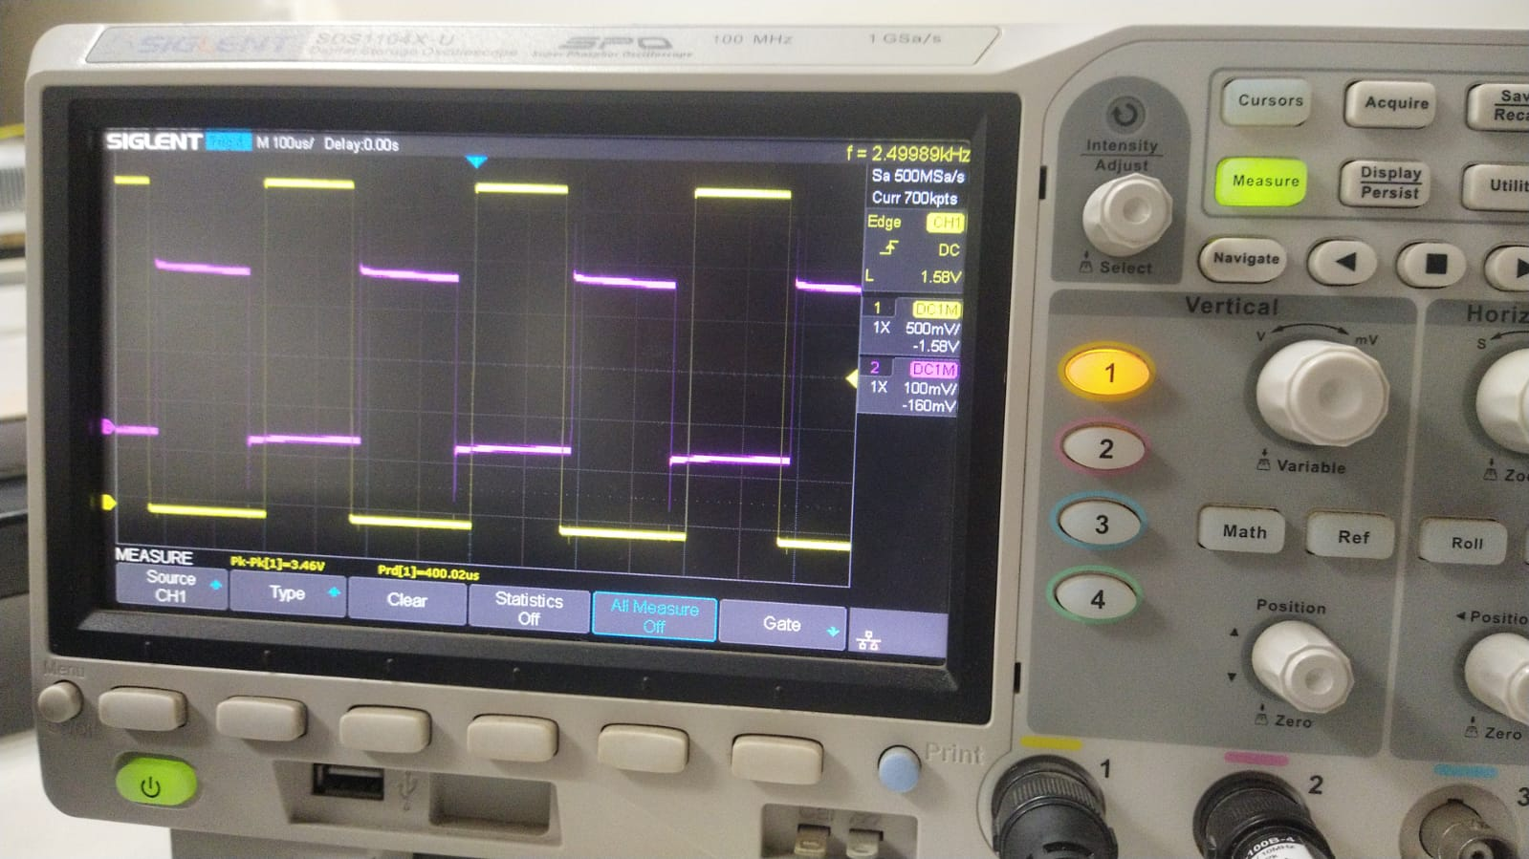

6. Code 4 — Software Phase-Locked Loop (PLL) using SOGI

6.1 Objective
To implement a complete software Phase-Locked Loop (PLL) on the C2000 F28379D that synchronizes a digital phase angle (theta) to an input AC voltage signal (e.g., single-phase grid voltage). The PLL uses a Second Order Generalized Integrator (SOGI) to generate quadrature (90°-shifted) signals and a PI controller to drive the phase error to zero. This is a fundamental algorithm in grid-connected inverters, STATCOMs, and active power filters.

6.2 Theory Background
6.2.1 Why PLL in Power Electronics?
Grid-connected converters must synchronize their output voltage/current with the grid. The PLL provides an accurate real-time estimate of the grid voltage phase angle (theta), which is used by the control algorithm for Park/Clarke transformations, grid synchronization, and islanding detection.

6.2.2 SOGI (Second Order Generalized Integrator)
The SOGI is a band-pass filter tuned to the grid frequency (omega). Given the measured AC voltage Va, it generates:
- Valpha (= sx1): In-phase component (same phase as Va)
- Vbeta (= sx2): Quadrature component (90° leading Va)
The SOGI state equations are:
err = Va - sx1
sx1 += (sqrt(2) * omega * err - omega * sx2) * Ts // Valpha
sx2 += (omega * sx1) * Ts // Vbeta

6.2.3 Park Transform (Vq Extraction)
The Park transform converts the (Valpha, Vbeta) frame to the rotating (d-q) frame using the estimated angle theta. The q-axis component Vq represents the phase error:
Vq = -Valpha * sin(theta) + Vbeta * cos(theta)
When the PLL is locked, theta matches the grid angle, Vq → 0.

6.2.4 PI Controller
A PI controller drives Vq to zero by adjusting the estimated frequency omega:
pi_int += KI * Vq * Ts (integral term, anti-windup ±100)
omega = W_NOM + KP*Vq + pi_int (proportional + integral correction)

6.3 Prerequisites
- ADC configured to sample grid voltage at 10 kHz (triggered by ePWM1 SOC)
- DAC A and DAC B available for real-time waveform output to oscilloscope
- math.h included — sinf() and cosf() available via TI C28x TMU (Trigonometric Math Unit)
- GPIO12 available for relay/sync pulse output
- GPIO31 for lock indicator LED
- Understanding of Park transform, PI controller, and anti-windup

6.4 Complete Code
#include "driverlib.h"
#include "device.h"
#include "math.h"

#define KP 50.0f
#define KI 500.0f
#define TWO_PI 6.28318f
#define W_NOM 314.159f // 50 Hz nominal angular frequency
#define TS 0.0001f // 10 kHz sample period

// PLL state variables
float theta = 0.0f;
float omega = W_NOM;
float pi_int = 0.0f;
float sx1 = 0.0f; // SOGI Valpha
float sx2 = 0.0f; // SOGI Vbeta

// Lock detection
#define LOCK_COUNT 50 // 50 samples × 0.1 ms = 5 ms
uint16_t lock_ctr = 0;
uint8_t locked = 0;
uint8_t synced = 0;

__interrupt void adcISR(void)
{
// 1. Read grid voltage from ADC
float Va = (ADC_readResult(ADCARESULT_BASE, ADC_SOC_NUMBER0)
/ 4095.0f * 3.3f) - 1.65f;

// 2. SOGI — generate Vbeta (quadrature)
float err = Va - sx1;
sx1 += (1.414f * omega * err - omega * sx2) * TS;
sx2 += (omega * sx1) * TS;

// 3. Park transform — extract Vq (phase error)
float Vq = -sx1 * sinf(theta) + sx2 * cosf(theta);

// 4. PI controller
pi_int += KI * Vq * TS;
if (pi_int > 100.0f) pi_int = 100.0f; // anti-windup
if (pi_int < -100.0f) pi_int = -100.0f;
omega = W_NOM + KP * Vq + pi_int;

// 5. Integrate omega to get theta
theta += omega * TS;
if (theta >= TWO_PI) theta -= TWO_PI;
if (theta < 0.0f) theta += TWO_PI;

// 6. DAC A — output theta sawtooth for oscilloscope
uint16_t dacA = (uint16_t)(theta / TWO_PI * 4095.0f);
DAC_setShadowValue(DACA_BASE, dacA);

// 7. DAC B — output |Vq| error magnitude for oscilloscope
float vq_display = (Vq + 1.65f) / 3.3f * 4095.0f;
if (vq_display > 4095.0f) vq_display = 4095.0f;
if (vq_display < 0.0f) vq_display = 0.0f;
DAC_setShadowValue(DACB_BASE, (uint16_t)vq_display);

// 8. Debounced lock detection
if (Vq > -0.01f && Vq < 0.01f)
{
if (lock_ctr < LOCK_COUNT) lock_ctr++;
}
else
{
lock_ctr = 0;
locked = 0;
}
if (lock_ctr >= LOCK_COUNT) locked = 1;

// 9. Auto-sync — close relay at theta = 0 after lock
if (locked && !synced && theta < 0.05f)
{
GPIO_writePin(12, 1); // close relay / assert gate signal
synced = 1;
}

// 10. LED indicator — ON when locked
GPIO_writePin(31, locked);

ADC_clearInterruptStatus(ADCA_BASE, ADC_INT_NUMBER1);
Interrupt_clearACKGroup(INTERRUPT_ACK_GROUP1);
}

void main(void)
{
Device_init();
Device_initGPIO();
Interrupt_initModule();
Interrupt_initVectorTable();

// GPIO12 = relay output
GPIO_setDirectionMode(12, GPIO_DIR_MODE_OUT);
GPIO_setPadConfig(12, GPIO_PIN_TYPE_STD);
GPIO_writePin(12, 0);

// GPIO31 = LED lock indicator
GPIO_setDirectionMode(31, GPIO_DIR_MODE_OUT);
GPIO_setPadConfig(31, GPIO_PIN_TYPE_STD);
GPIO_writePin(31, 0);

// DAC A init
DAC_setReferenceVoltage(DACA_BASE, DAC_REF_ADC_VREFHI);
DAC_setLoadMode(DACA_BASE, DAC_LOAD_SYSCLK);
DAC_setShadowValue(DACA_BASE, 0);
DAC_enableOutput(DACA_BASE);

// DAC B init
DAC_setReferenceVoltage(DACB_BASE, DAC_REF_ADC_VREFHI);
DAC_setLoadMode(DACB_BASE, DAC_LOAD_SYSCLK);
DAC_setShadowValue(DACB_BASE, 2048); // mid-scale = 0 error
DAC_enableOutput(DACB_BASE);

// ADC init
ADC_setPrescaler(ADCA_BASE, ADC_CLK_DIV_4_0);
ADC_setMode(ADCA_BASE, ADC_RESOLUTION_12BIT, ADC_MODE_SINGLE_ENDED);
ADC_enableConverter(ADCA_BASE);
DEVICE_DELAY_US(1000);
ADC_setupSOC(ADCA_BASE, ADC_SOC_NUMBER0, ADC_TRIGGER_EPWM1_SOCA,
ADC_CH_ADCIN0, 15);
ADC_setInterruptSource(ADCA_BASE, ADC_INT_NUMBER1, ADC_SOC_NUMBER0);
ADC_enableInterrupt(ADCA_BASE, ADC_INT_NUMBER1);
ADC_clearInterruptStatus(ADCA_BASE, ADC_INT_NUMBER1);

SysCtl_disablePeripheral(SYSCTL_PERIPH_CLK_TBCLKSYNC);

// EPWM1: 10 kHz ADC trigger
EPWM_setTimeBasePeriod(EPWM1_BASE, 10000U);
EPWM_setTimeBaseCounterMode(EPWM1_BASE, EPWM_COUNTER_MODE_UP);
EPWM_setClockPrescaler(EPWM1_BASE, EPWM_CLOCK_DIVIDER_1,
EPWM_HSCLOCK_DIVIDER_1);
EPWM_enableADCTrigger(EPWM1_BASE, EPWM_SOC_A);
EPWM_setADCTriggerSource(EPWM1_BASE, EPWM_SOC_A, EPWM_SOC_TBCTR_PERIOD);
EPWM_setADCTriggerEventPrescale(EPWM1_BASE, EPWM_SOC_A, 1);

SysCtl_enablePeripheral(SYSCTL_PERIPH_CLK_TBCLKSYNC);

Interrupt_register(INT_ADCA1, &adcISR);
Interrupt_enable(INT_ADCA1);
EINT;
ERTM;

for (;;) {}
}

6.5 Line-by-Line Explanation — ISR (adcISR)
Step / Code Block | Explanation
Step 1: ADC_readResult(...) / 4095.0f * 3.3f - 1.65f | Reads the 12-bit ADC result (0–4095), converts to voltage (0–3.3 V), then offsets by -1.65 V to obtain a bipolar signal (-1.65 V to +1.65 V) representing the AC grid voltage centered at zero.
Step 2: SOGI state update (sx1, sx2) | Implements the discrete-time SOGI equations. sx1 is the band-pass filtered Valpha (in-phase with Va), sx2 is the low-pass filtered Vbeta (90° phase-lagged). Together they form a stationary alpha-beta frame representation of the input signal.
Step 3: Vq = -sx1*sinf(theta) + sx2*cosf(theta) | Park transform on the (sx1, sx2) vector using the PLL's current angle estimate (theta). The q-axis component Vq is zero when theta matches the actual grid angle. A positive Vq means theta is lagging; negative means leading.
Step 4: PI controller with anti-windup | Integral accumulator pi_int is updated with KI×Vq×Ts. Clamped to ±100 rad/s to prevent integrator windup during large transients. omega is updated as W_NOM + KP×Vq + pi_int — the PLL's frequency estimate.
Step 5: theta += omega * TS; wrap to [0, 2π] | Integrates the angular frequency omega to produce the phase angle theta. The if-else statements wrap theta within [0, 2π] to prevent floating-point overflow over long run times.
Step 6: DAC A — theta sawtooth | Scales theta (0 to 2π) to the 12-bit DAC range (0–4095) and outputs it. On the oscilloscope this appears as a 50 Hz sawtooth wave. When locked, the sawtooth period exactly matches the grid period.
Step 7: DAC B — Vq error | Scales Vq (typically ±1.65 V) to the DAC range and outputs it. Before lock: large oscillating signal. After lock: flatlines near mid-scale (2048 = 0 V error). Used to visually confirm lock on oscilloscope.
Step 8: Debounced lock detection | Requires 50 consecutive ISR samples (5 ms) with |Vq| < 10 mV to assert locked = 1. Single-sample lock detection is noise-sensitive; debouncing improves reliability.
Step 9: Auto-sync — GPIO12 | Once locked, waits for theta to pass through zero (0 to 0.05 rad window ≈ 3°) then asserts GPIO12. This fires a relay or IGBT gate signal exactly at the grid zero-crossing — enabling seamless grid connection of an inverter.
Step 10: LED + interrupt clear | GPIO31 LED is lit while PLL is locked. ADC interrupt flag and PIE group acknowledge are cleared to allow the next ADC interrupt to fire.

6.6 Line-by-Line Explanation — main()
Code Block | Explanation
DAC_setReferenceVoltage(..., DAC_REF_ADC_VREFHI) | Uses the ADC VREFHI pin (3.3 V) as the DAC reference. Ensures ADC and DAC use the same reference — important for accurate Vq scaling.
DAC_setLoadMode(..., DAC_LOAD_SYSCLK) | DAC shadow register is loaded on the system clock edge. Provides synchronous, glitch-free updates every time DAC_setShadowValue() is called.
ADC_setPrescaler(..., ADC_CLK_DIV_4_0) | Sets ADC clock = SYSCLK/4 = 50 MHz. C2000 ADC operates up to 50 MHz — this setting maximizes conversion speed.
ADC_setupSOC(..., ADC_TRIGGER_EPWM1_SOCA, ADC_CH_ADCIN0, 15) | Configures ADC Start-Of-Conversion 0: triggered by ePWM1 SOC-A event, sampling channel ADCIN0 (analog input pin), with 15 ADCCLK cycle acquisition window. The trigger source (ePWM1) ensures ADC sampling is synchronized to the PWM period.
EPWM_setTimeBasePeriod(EPWM1_BASE, 10000U) | ePWM1 is configured purely as an ADC trigger generator. TBPRD = 10000 with CLKDIV=1, HSPCLKDIV=1, SYSCLK=200 MHz: f_trigger = 200M/10000 = 20 kHz (up-count mode, period = TBPRD). Resulting ADC sample rate: 10 kHz (SOC triggered once per period).
EPWM_setADCTriggerSource(..., EPWM_SOC_TBCTR_PERIOD) | Fires the ADC SOC-A event when the time base counter reaches TBPRD (period). This gives a precise, hardware-timed 10 kHz ADC sampling rate synchronized to ePWM1.
Interrupt_register(INT_ADCA1, &adcISR) | Registers adcISR as the ISR for ADC-A interrupt 1 in the PIE vector table. This links the hardware interrupt vector to the software ISR function.

6.7 PLL Parameter Summary
Parameter | Value | Rationale
Sample rate (Ts) | 100 µs (10 kHz) | Nyquist: 10× the 50 Hz grid fundamental — provides good tracking bandwidth.
KP (Proportional gain) | 50.0 | Provides fast initial frequency correction. Higher KP gives faster pull-in but more noise sensitivity.
KI (Integral gain) | 500.0 | Provides zero steady-state phase error. KI/KP = 10 → bandwidth ≈ 10 rad/s (typical for grid PLL).
W_NOM (Nominal freq) | 314.159 rad/s (50 Hz) | Initial frequency estimate. Feeds PI controller forward path for fast lock.
LOCK_COUNT | 50 samples (5 ms) | Debounce window before declaring lock. Prevents false lock during noise bursts.
Anti-windup limit | ±100 rad/s | Limits integrator to ±16 Hz frequency deviation — handles ±10% grid frequency variation.

Chanel 1 & Chanel 2 output

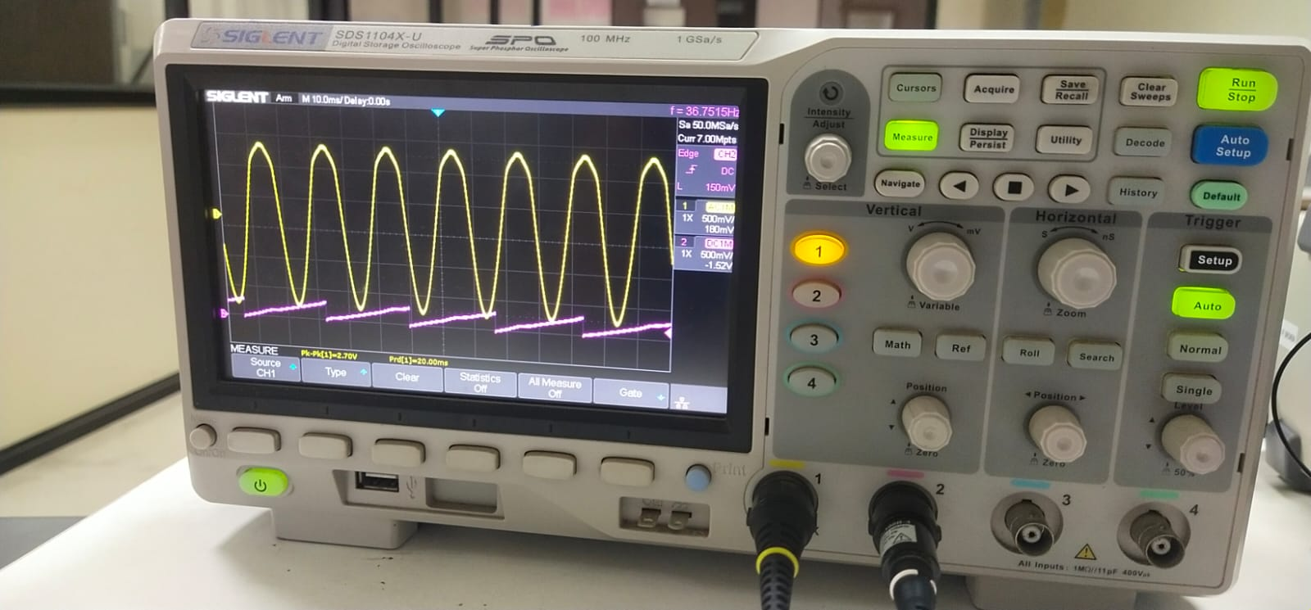

Chanel 1 & Chanel 3 Output

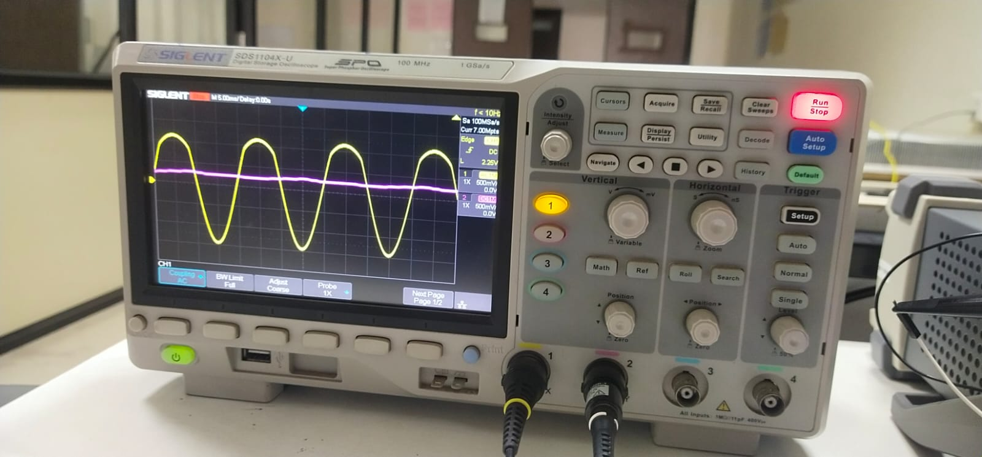

9. References
- Texas Instruments, TMS320F28379D Datasheet (SPRS880), Texas Instruments Inc., Rev. I, 2021.
- Texas Instruments, C2000 DriverLib API Reference Guide (SPRU998), Texas Instruments Inc.
- Texas Instruments, C2000Ware Software Package Documentation, available: https://www.ti.com/tool/C2000WARE
- Texas Instruments, LAUNCHXL-F28379D LaunchPad User's Guide (SPRUI74), Texas Instruments Inc.
- R. Teodorescu, M. Liserre, P. Rodriguez, Grid Converters for Photovoltaic and Wind Power Systems, Wiley-IEEE Press, 2011.
- Texas Instruments, Technical Reference Manual: Enhanced Pulse Width Modulator (ePWM) Module (SPRUGE5), TI Inc.
- Texas Instruments, Code Composer Studio v12 Getting Started Guide, available: https://www.ti.com/tool/CCSTUDIO

